Dhrish E0320008

Services - Vpc - Vpc console

Top left - new vpc experience – toggle button on

Vpc dashboard - create vpc

Vpc and more

Auto generate - selected

Change project -> lab

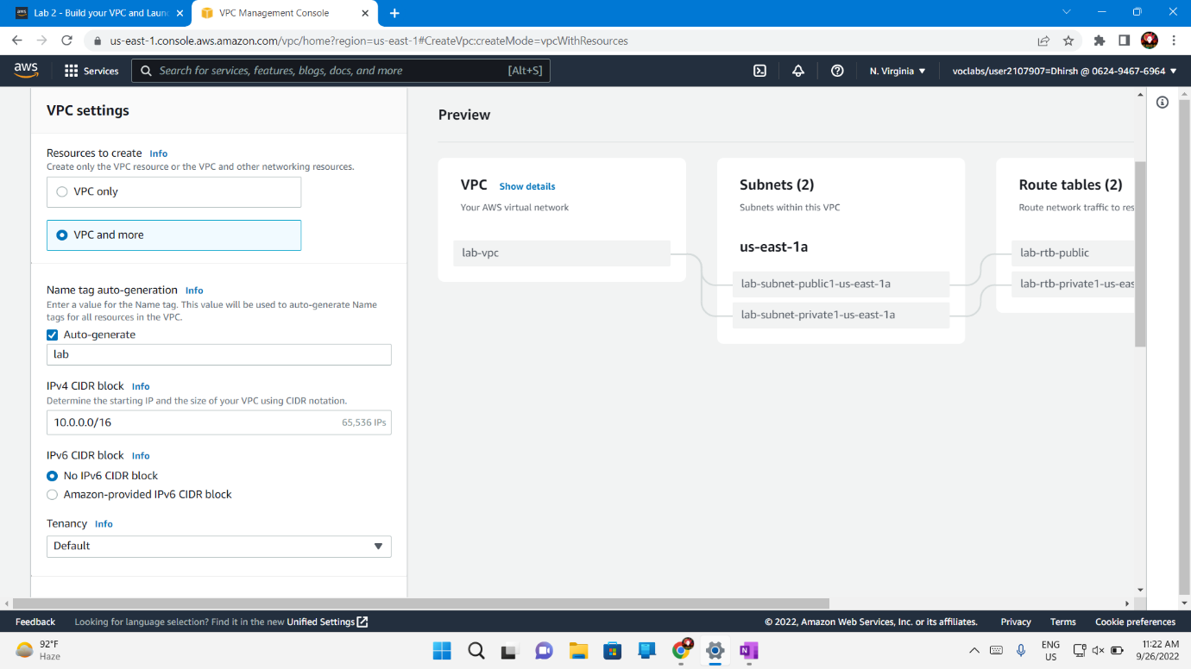

Keep ipv4 default

Availability zone - 1

Public subnet - 1

Private subnet - 1

Customize subnet cidr block -

Public and private subnet - 10.0.0.0/24 and 10.0.1.0/24

Nat gateway - in 1 AZ

Vpc endpoints - none

Keep both **DNS hostnames** and **DNS resolution** *enabled*

Create VPC

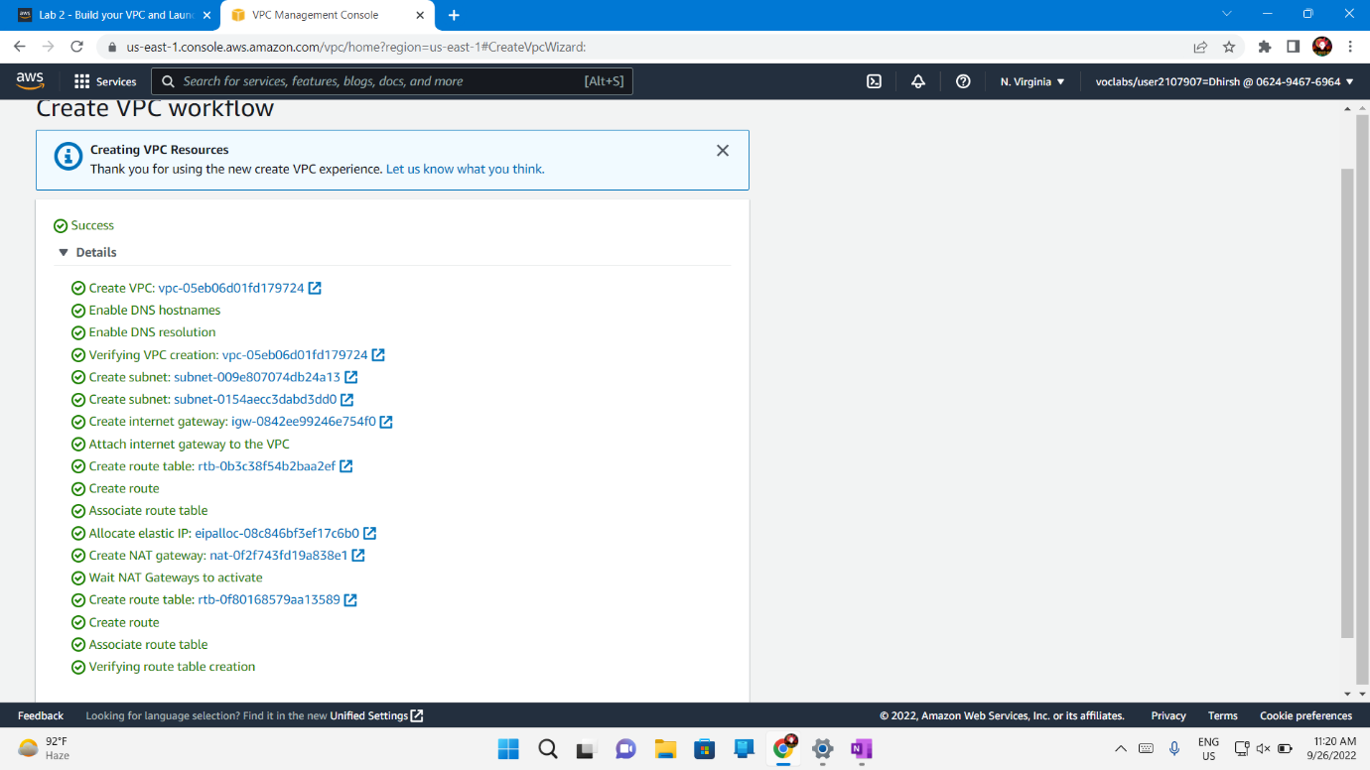

END LAB

TASK 2

**Create Additional Subnets**

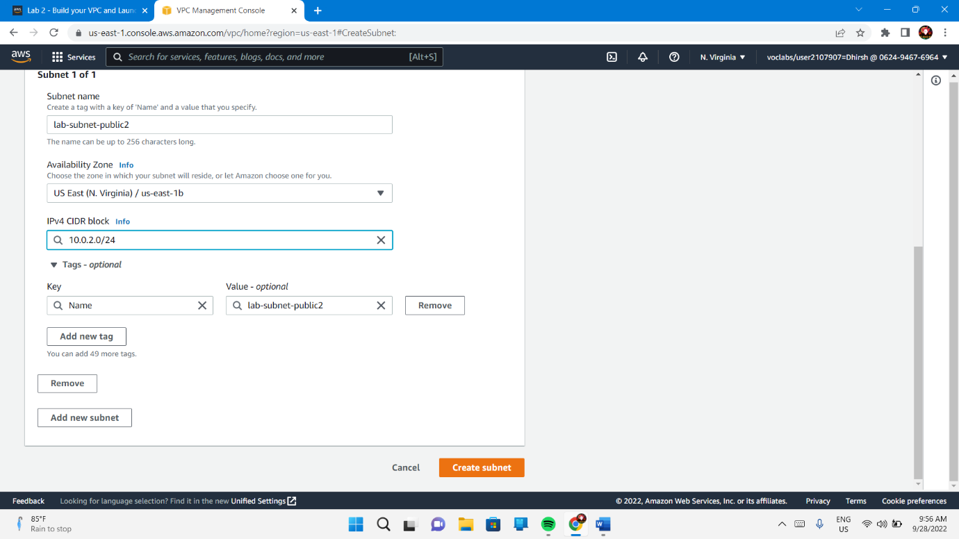

VPC – Subnet – Create Subnet

ID : lab-vpc from drop-down

Subnet name : lab-subnet-public2

Availability Zone – us-east-1b

**IPv4 CIDR block:** 10.0.2.0/24

Availability Zone – us-east-1b

Note : The subnet will have all IP addresses starting with **10.0.2.x**.

The second public subnet was created. You will now create a second private subnet.

Created.

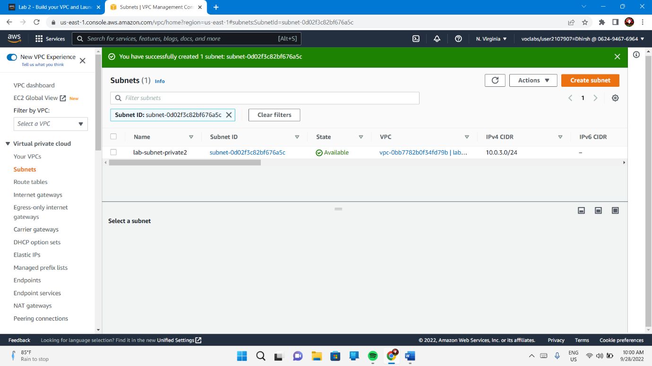

ID : lab-vpc from drop-down

Subnet name : lab-subnet-private2

Availability Zone – us-east-1b

**IPv4 CIDR block:** 10.0.3.0/24

Availability Zone – us-east-1b

The subnet will have all IP addresses starting with **10.0.3.x**.

Created.

Note : configure this new private subnes to route internet-bound traffic to the NAT Gateway so that resources in the second private subnet are able to connect to the Internet, while still keeping the resources private. This is done by configuring a Route Table.

A route table contains a set of rules, called routes, that are used to determine where network traffic is directed. Each subnet in a VPC must be associated with a route table; the route table controls routing for the subnet.

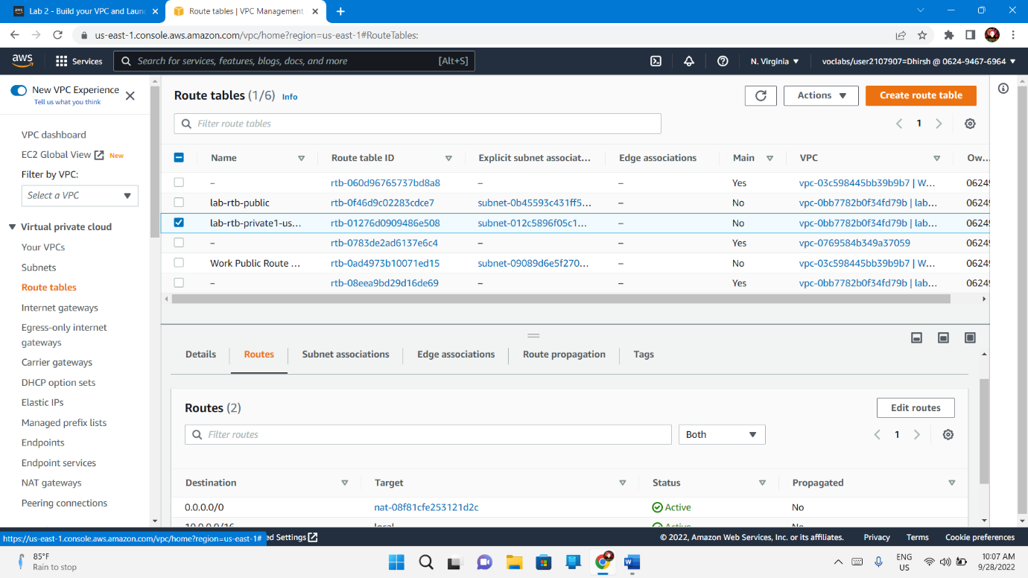

Route Tables – Select **lab-rtb-private1-us-east-1a** route table.

Routes Tab – Subnet Association – Edit Subnet Association - Leave **lab-subnet-private1-us-east-1a** selected, but also select **lab-subnet-private2** -Save Association

Route Tables – Select **lab-rtb-public** route table

**Subnet associations** tab - Edit Subnet Association - Leave **lab-subnet-public1-us-east-1a** selected, but also select **lab-subnet-public2** – Save Association

End Lab.